**LAB 1 MOOCV Application**

**Team Details Lab Id: 10**

**Name:**Shruthi Pinnamwar

**Email Id:**spdb6@mail.umkc.edu

**Class Id:**21

**Name:**Anusha Muppalla

**Email Id:**amfb7@mail.umkc.edu

**Class Id:**17

**Name:**Vidyullatha Lakshmi Kaza

**Email Id:**vkrwc@mail.umkc.edu

**Class Id:**11

**Objective:**

Our objective is to design a Massive Open Online Course (MOOC) Web application using HTML, CSS, JavaScript, jQuery, AJAX, Bootstrap concepts taught in class.

**Source Code :**[**Source Code**](https://github.com/shruthipinnamwar/CS5590-Web-Programming-Labs/tree/master/Lab1/Source/medino)

**Video Link :**[**https://youtu.be/ThK4hVuRn1s**](https://github.com/shruthipinnamwar/CS5590-Web-Programming-Labs/wiki/Video)

**Description:**

**Massive Open Online Course (MOOC) Web application website contains tabs for**

**1. Home Page**

**2. Login & Registration Page**

**3. Professors**

**4. Course Details**

**5. Order Details**

**6. Contact Page**

**Home Page**

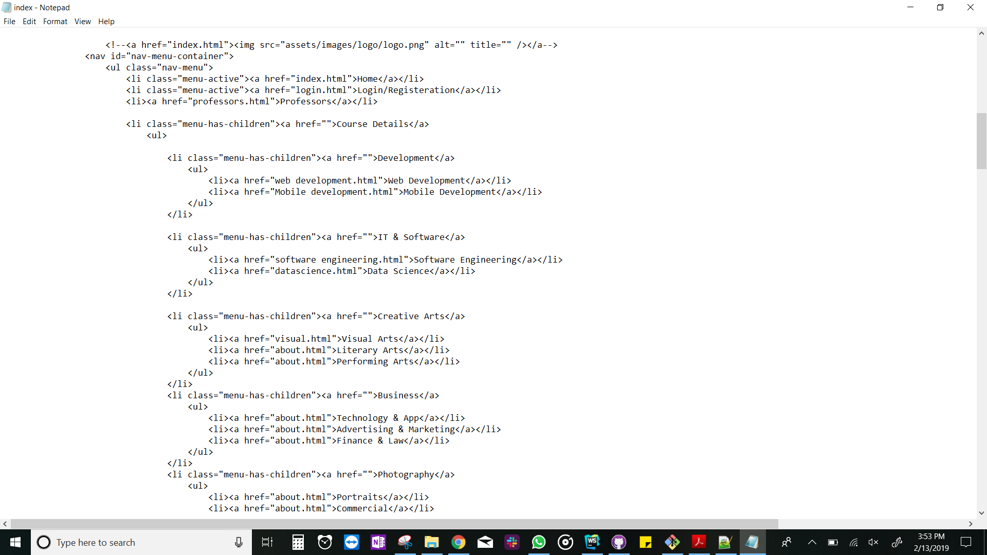



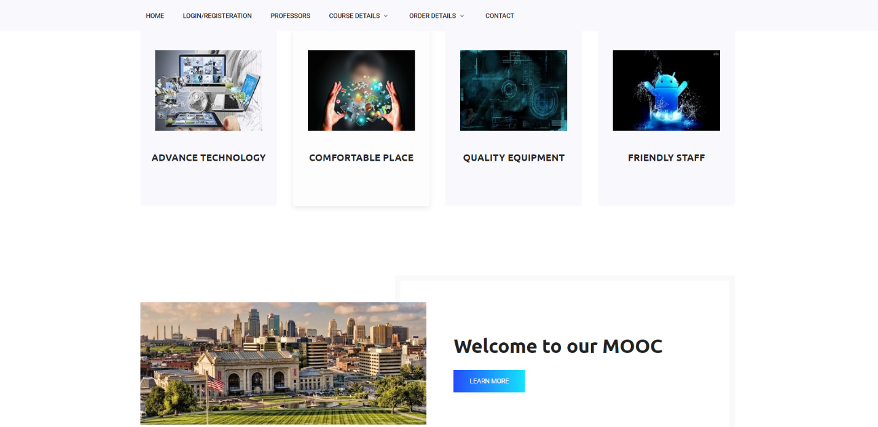

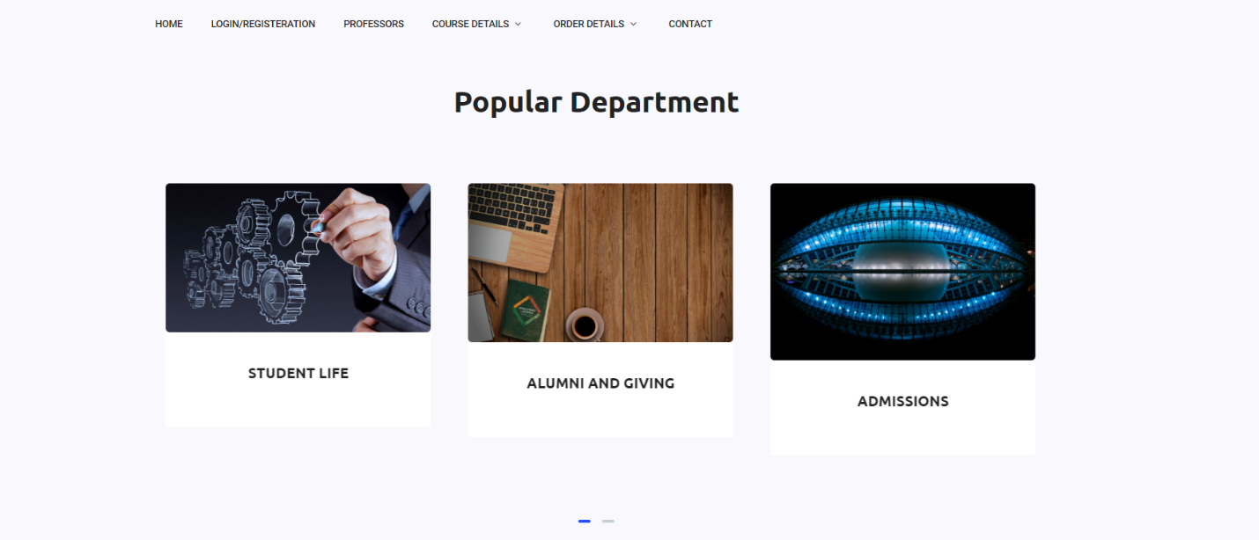

**Login & Registration Page:**

**I n this page, User can be able to login into the website by giving their credentials like username and Password and will be able to create an account.**

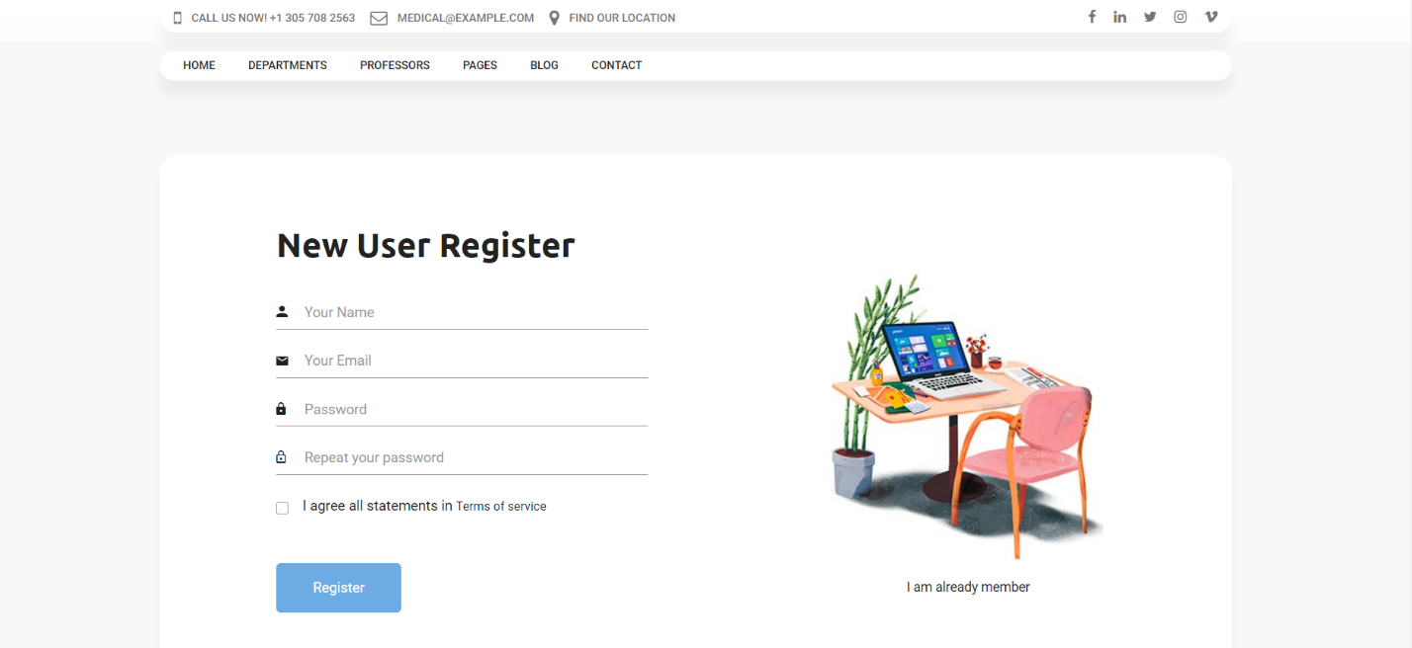

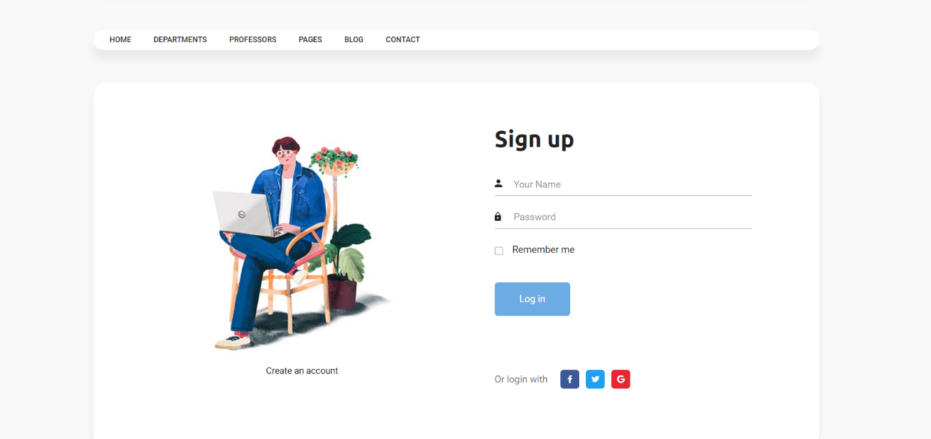

**Contact Page:**

**The user can fill the contact Form in the contact page to reach out about the courses. Used Javscript to validate form elements too. The user cannot leave any field blank nor he can give invalid input for email etc.**



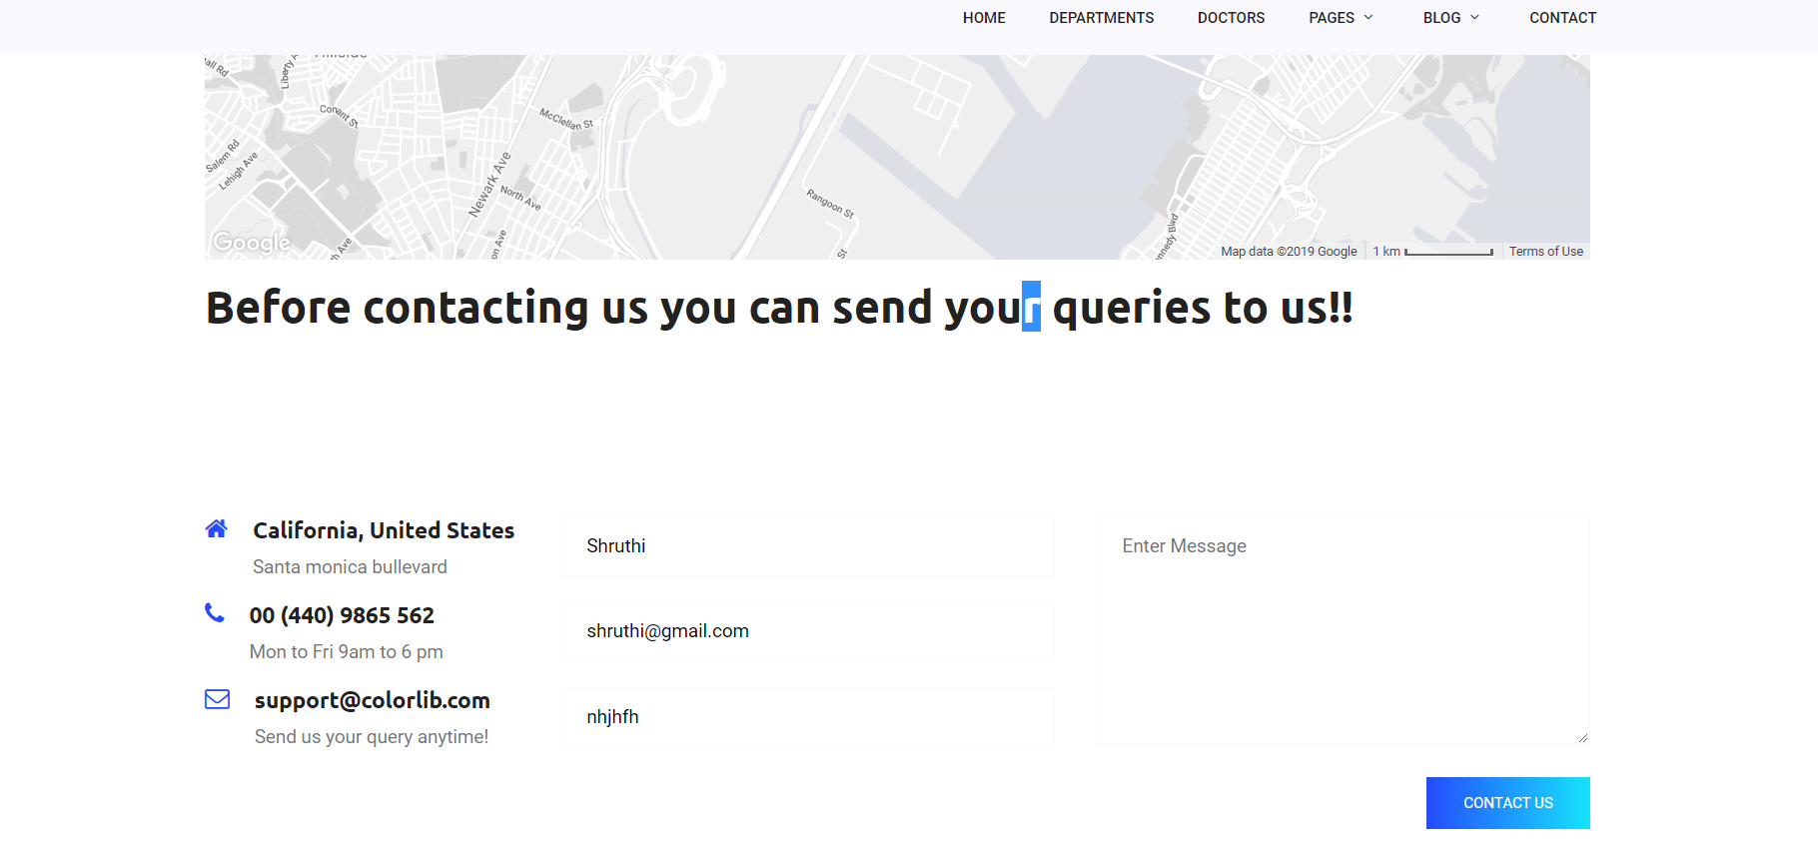

**Professors Page:**

**We used HTML tags like list, section, div, span and basic elements. Bootstrap elements like grid container and CSS elements like hover.**



**Course Details:**

**Mobile development page contains basic tags of HTML, bootstrap and CSS.**



Data science page contains images, registration form, checkbox, switches, list, grid container.

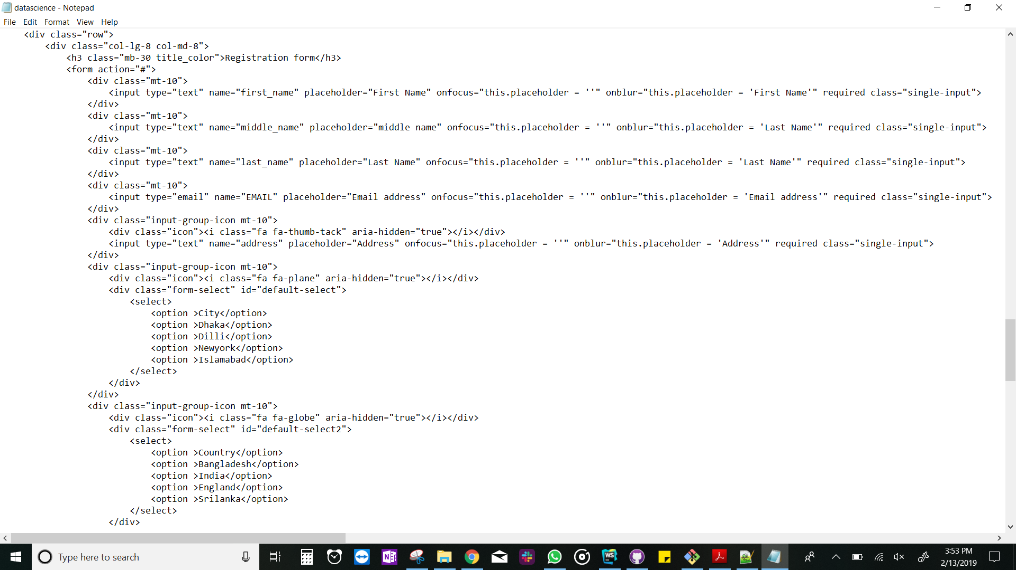

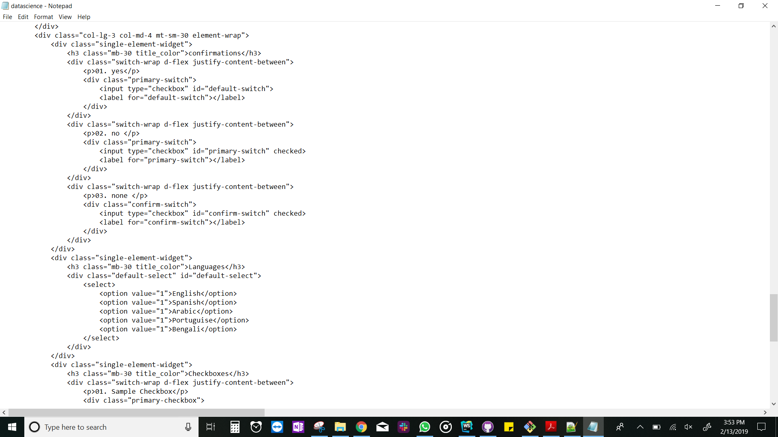

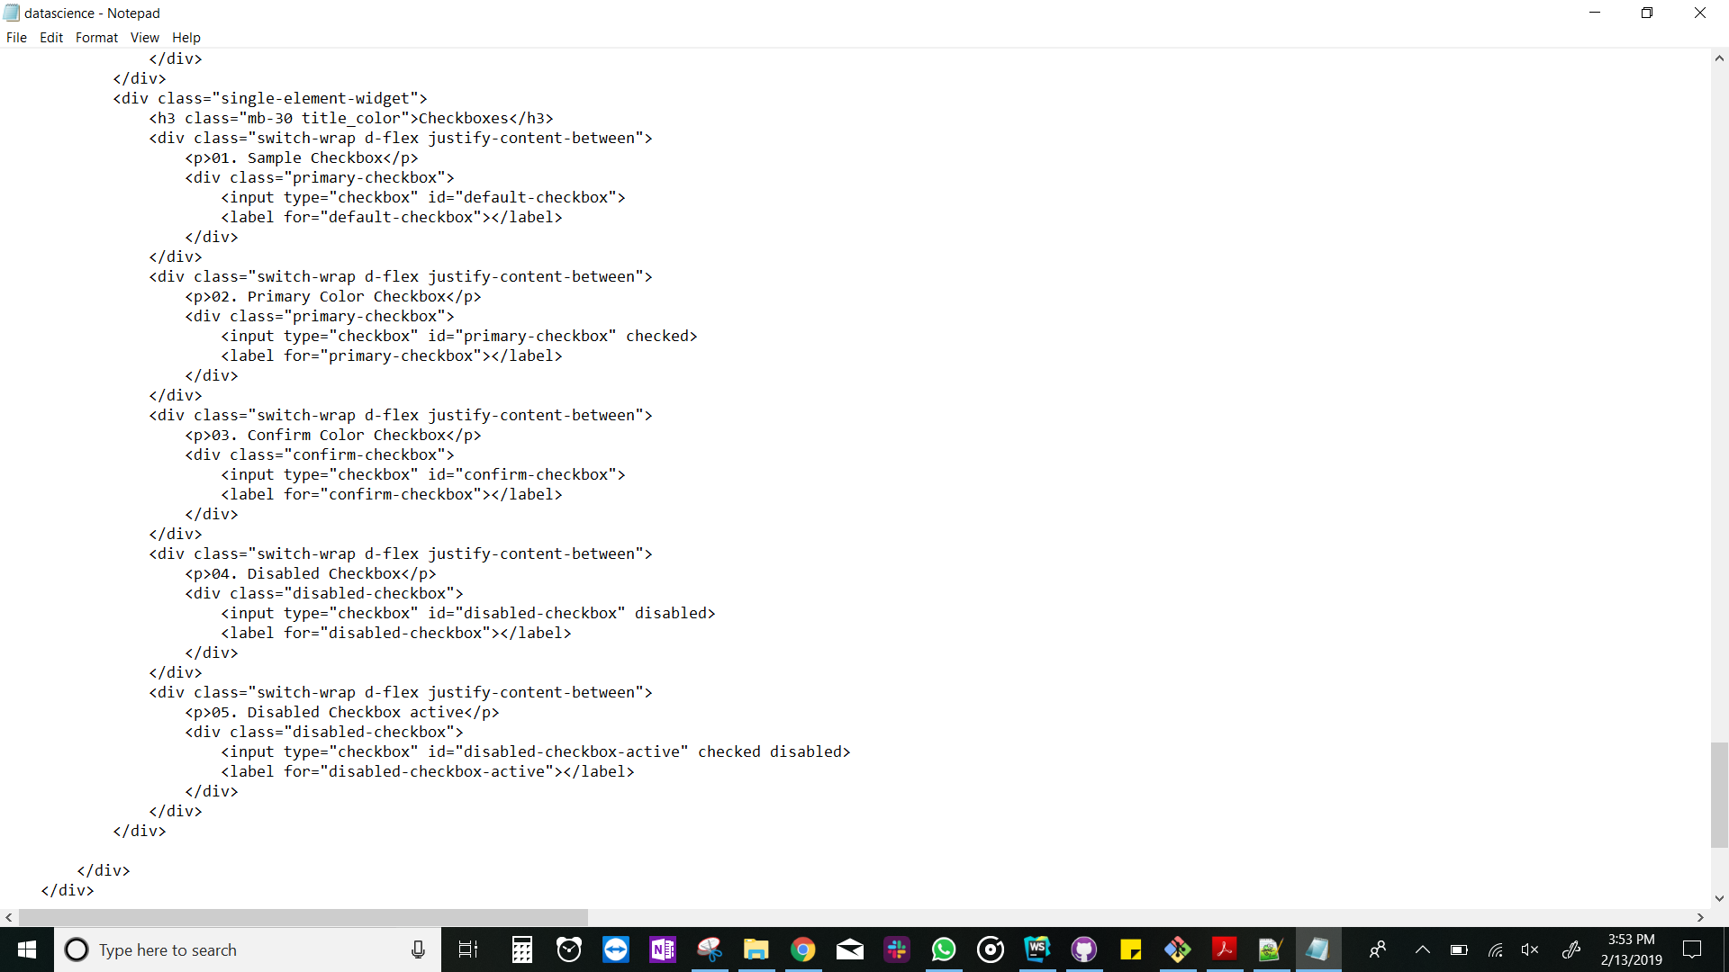

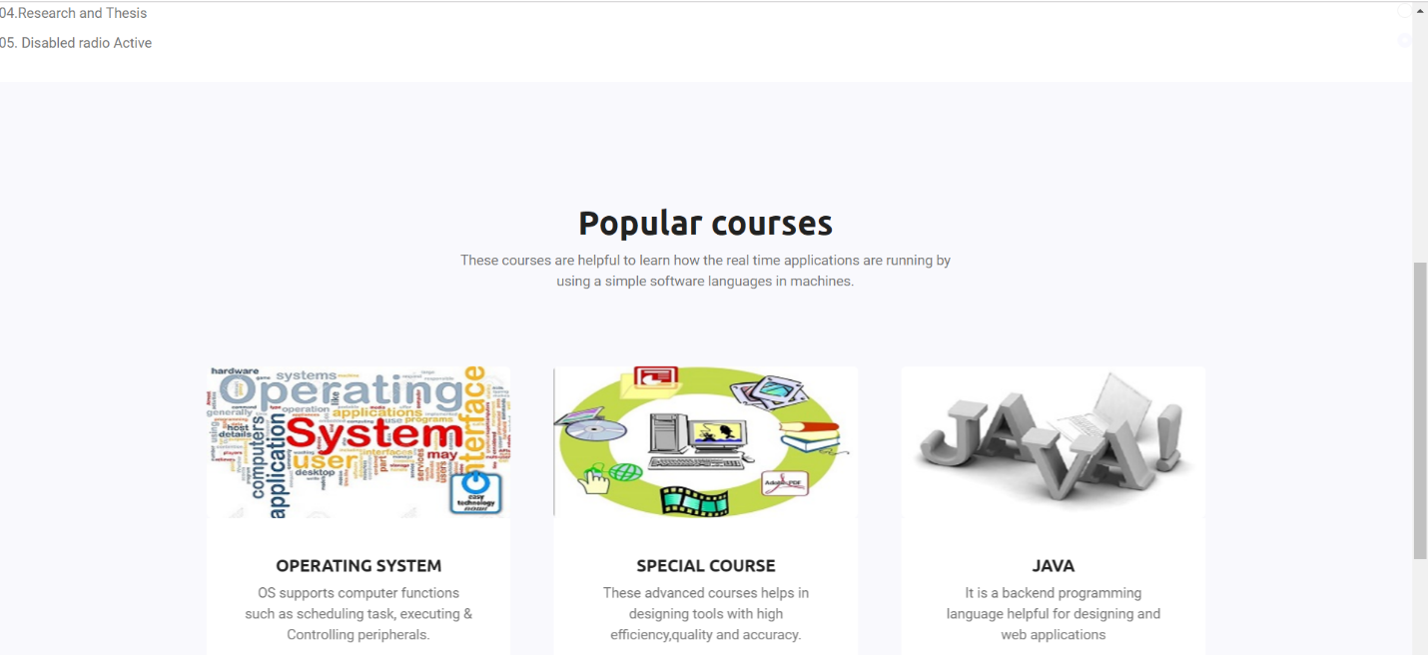

**Software Engineering page contains image slides for courses and radio buttons for options.**

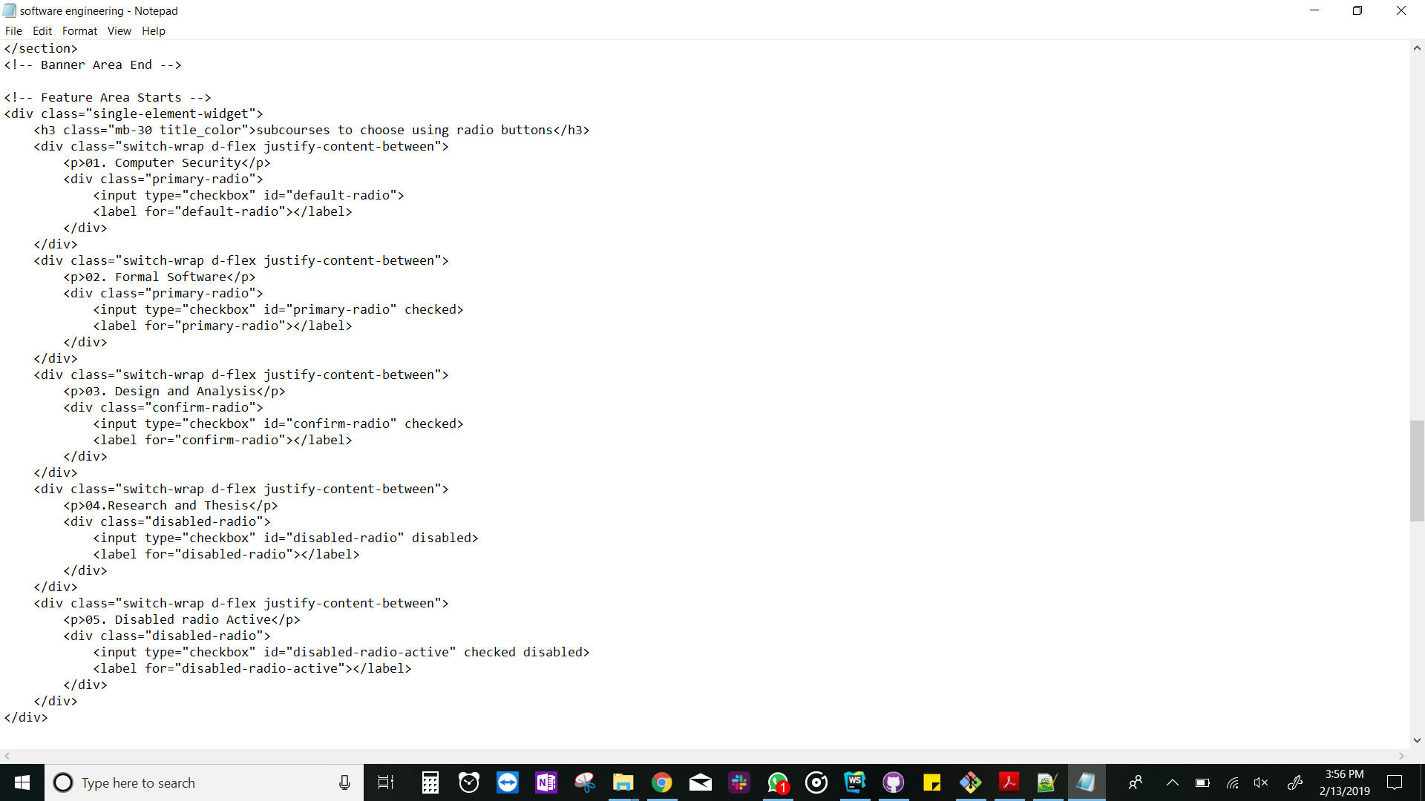

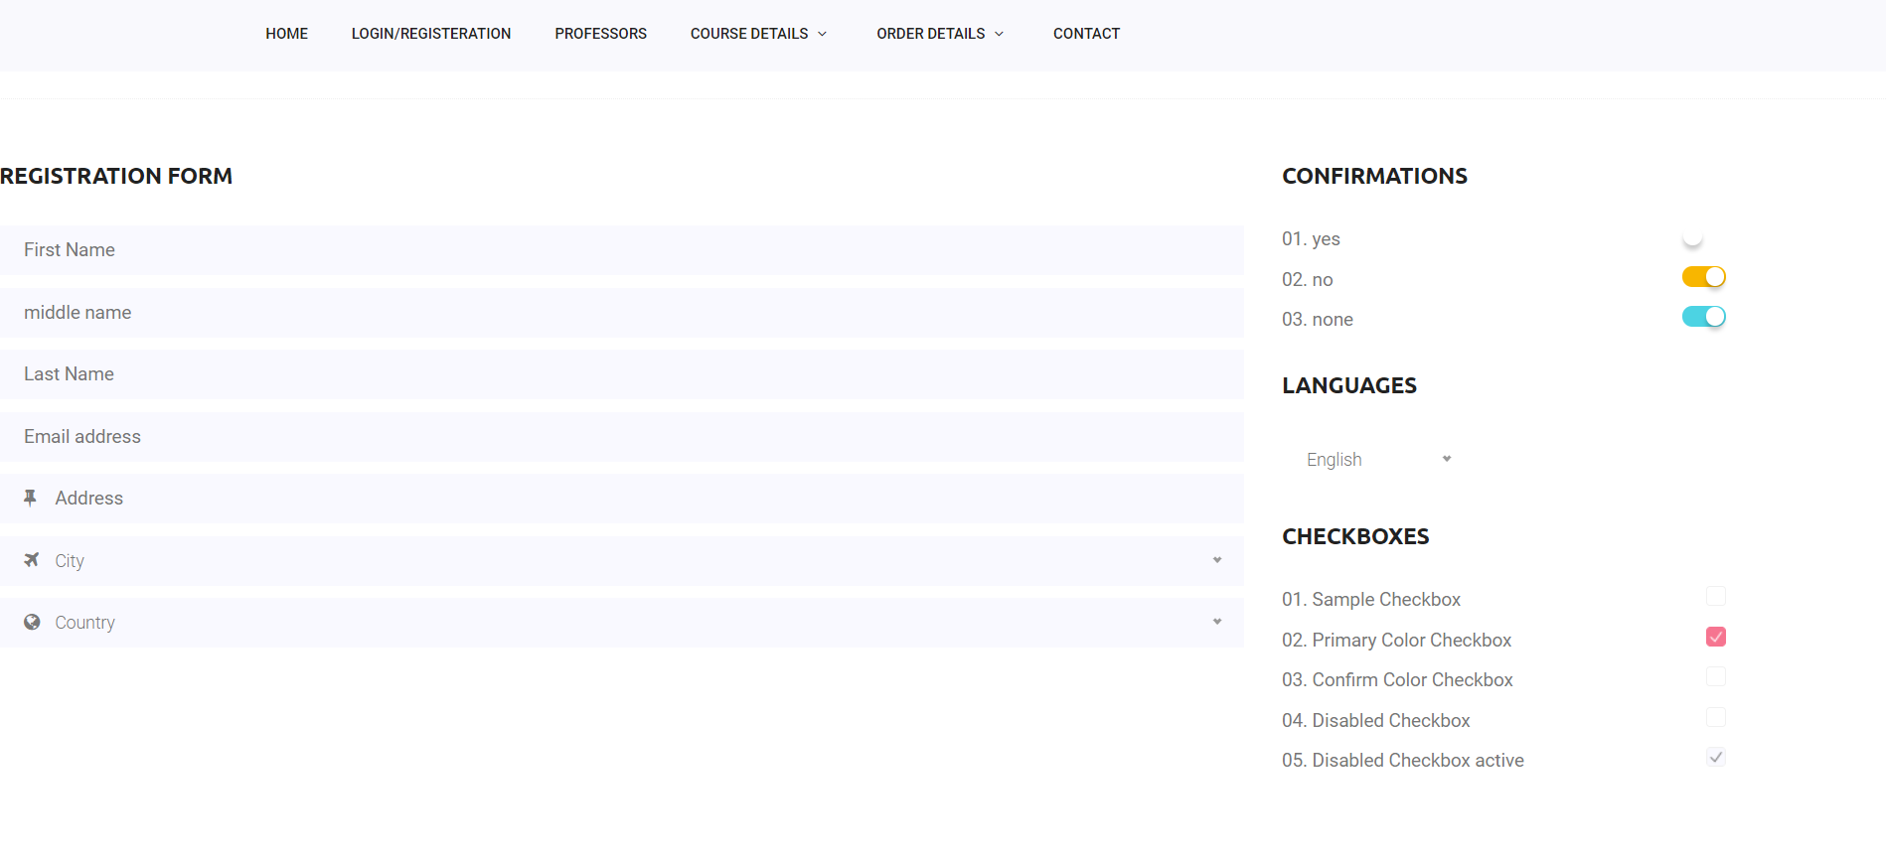



**Visual Arts contains all heading tags, gallery slider using animation tags in CSS**

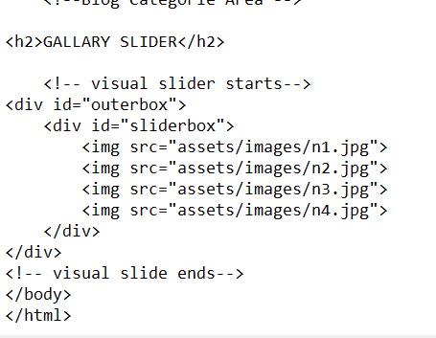

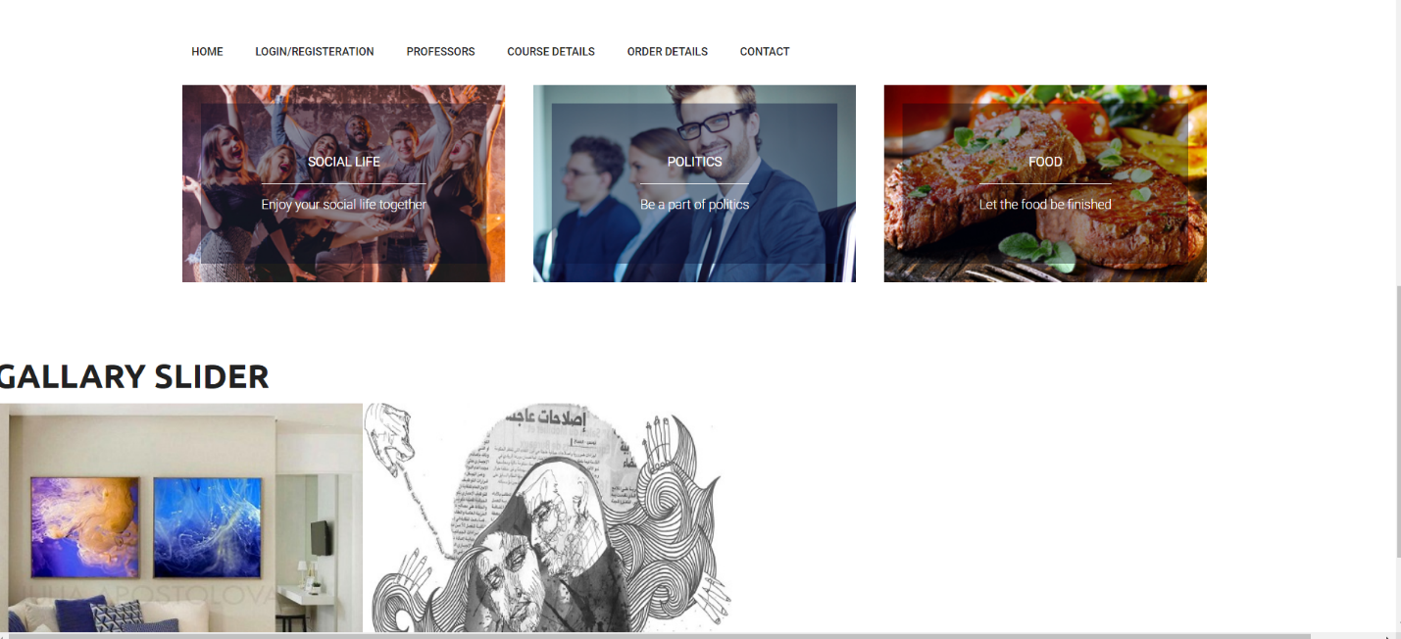

**Order Details:**

**Orders page contains student recent orders using span and div elements in HTML and used navigation elements using jquery and old orders.**



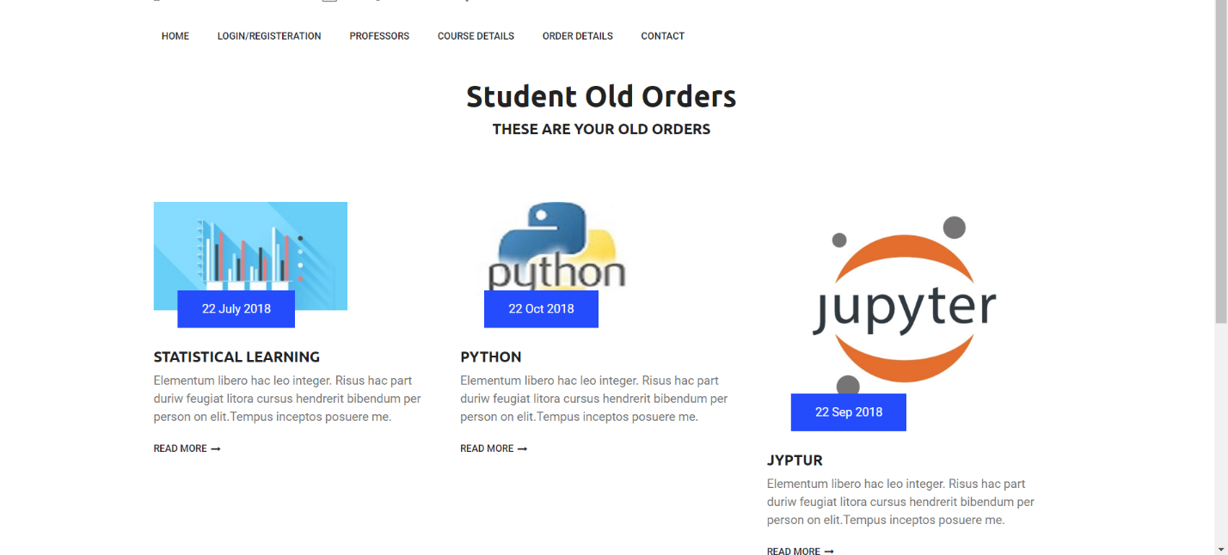

**References :**[**https://www.w3schools.com**](https://www.w3schools.com/)**,**[**https://developer.mozilla.org/en-US/**](https://developer.mozilla.org/en-US/)**, Bootstrap Template :**[**https://colorlib.com/wp/template/medino/**](https://colorlib.com/wp/template/medino/)